North Marston PC Report
1st Granborough Scouts
May 2017

Our Group

The 1st Granborough Group consists of Beavers (ages 6-8), Cubs (ages 8-10 ½) & Scouts (10 ½ -14). The current membership breakdown is as follows;
Beavers 24 members & 7 leaders
Cubs 19 members & 3 leaders
Scouts 29 members & 6 leaders

We currently operate a waiting list on all three sections and manage this by referring enquiries to other Groups (Winslow or Steeple Claydon). We are limited by our meeting venue. NM School rent us their hall but it has poor acoustics and the size limits us to approximately 25 young people. More than this and the space becomes cramped.

What we are up to

2017 is another busy year for our groups. Here are a few of our plans

- 1st aid training

- Scavenger hunt

- Kayaking

- Over night 10 mile hike carrying all their kit, then crossing a river on aerial rope way they built

- Visit to an F1 team !

- Cooking long distance hot dogs

- Making a tin can burner

- Making a water filter

- Summer camp

A week away doing the following
Building and riding an Aerial Runway, Cooking complex meals on open fires, building and racing Rocket powered Spitfire, Kayaking down the River Wye, Rock climbing, Swimming, Wide games, Climbing Pen Y Fan in the Brecon Beacons, Tour of Morgan Sports Car Factory, Backwoods cooking, Pioneering, Shelter building, Lots of Teamwork, Building camp gadget, Leaning new skills, Camp Water slide and generally having fun!

- Gliding

- Gutting fish and cooking on an open fire

- Gutting and plucking birds

- Lots of night navigation exercises

- Walks and talks about our local area and its history

- Presentations by an amazing array of local people; giving the group an insight into all sorts of jobs, businesses and charities

- Annual support of Granborough Santa’s Float and Charter Fair

Scout Troop Executive Committee

This report has been prepared and is supported by the following Executive members:
Chair Peter Butler
Treasurer Sue Mordue
Secretary Lisa Simmons
Group Scout Leader Mark Weedon
Scout Leader Bob Bowerman
Cub Leader Martie Hancock
Beaver Leader Karen Brook
Quartermaster Steve Parslow
Parent Representative Emma Shovlin
Parent Representative Simon Mills

The Troop in Action!!

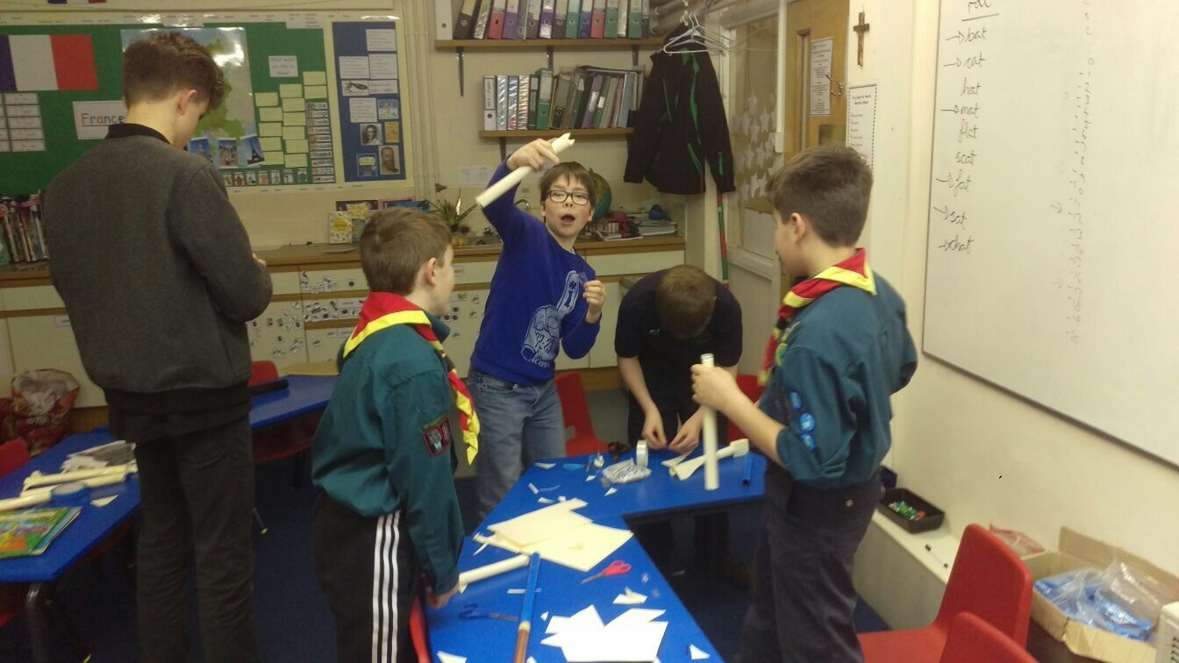
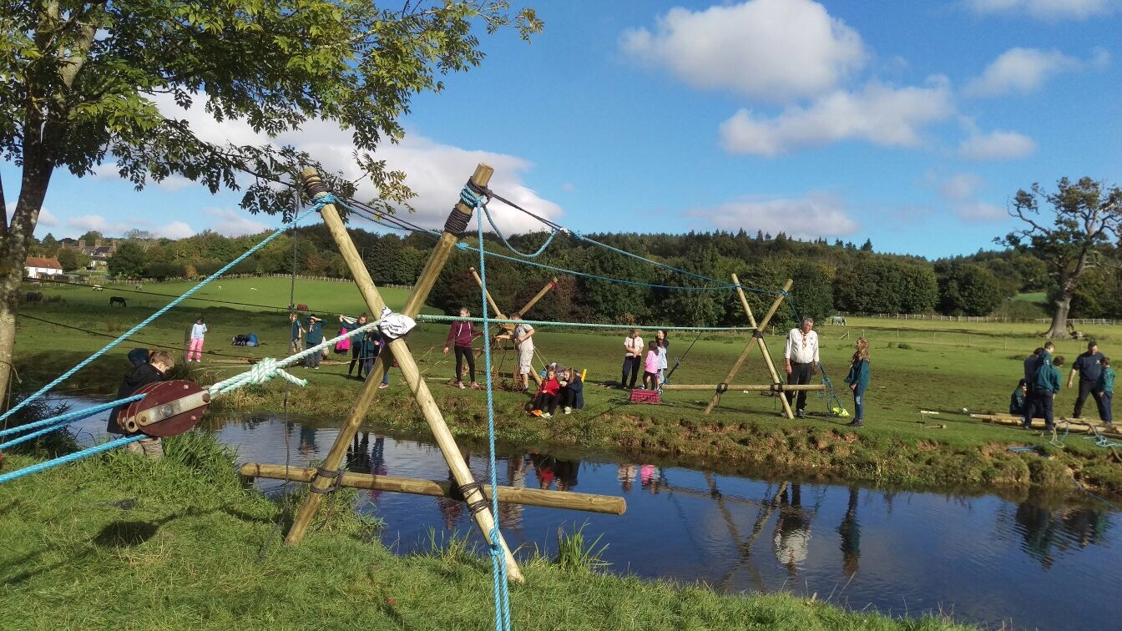
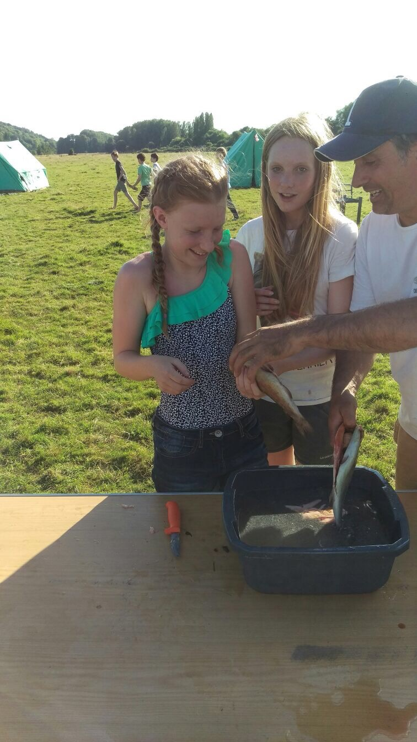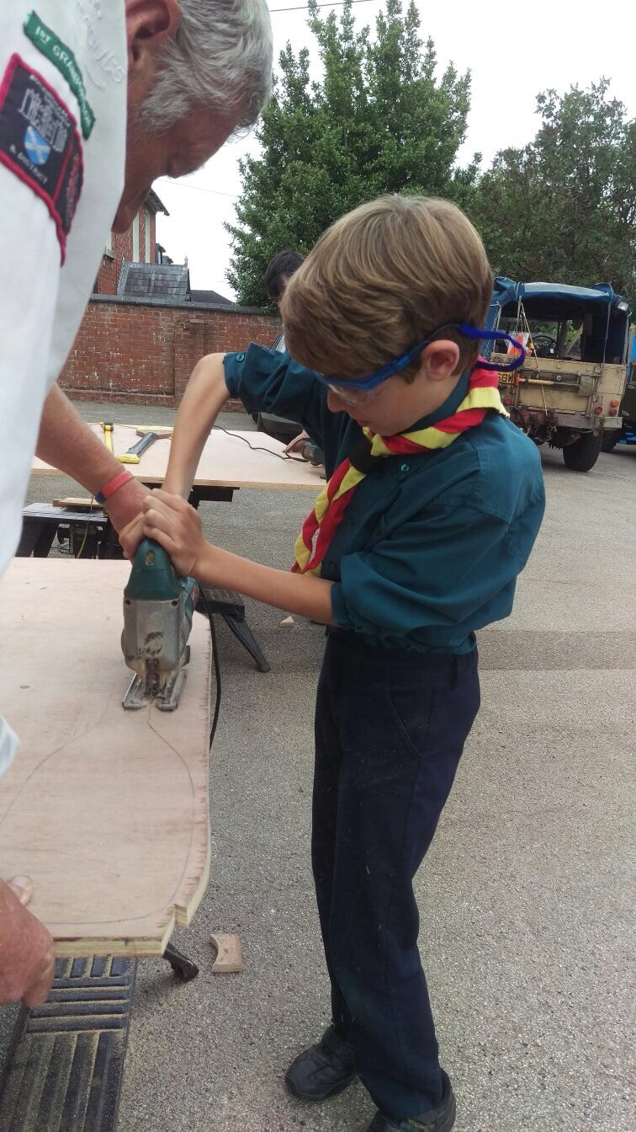
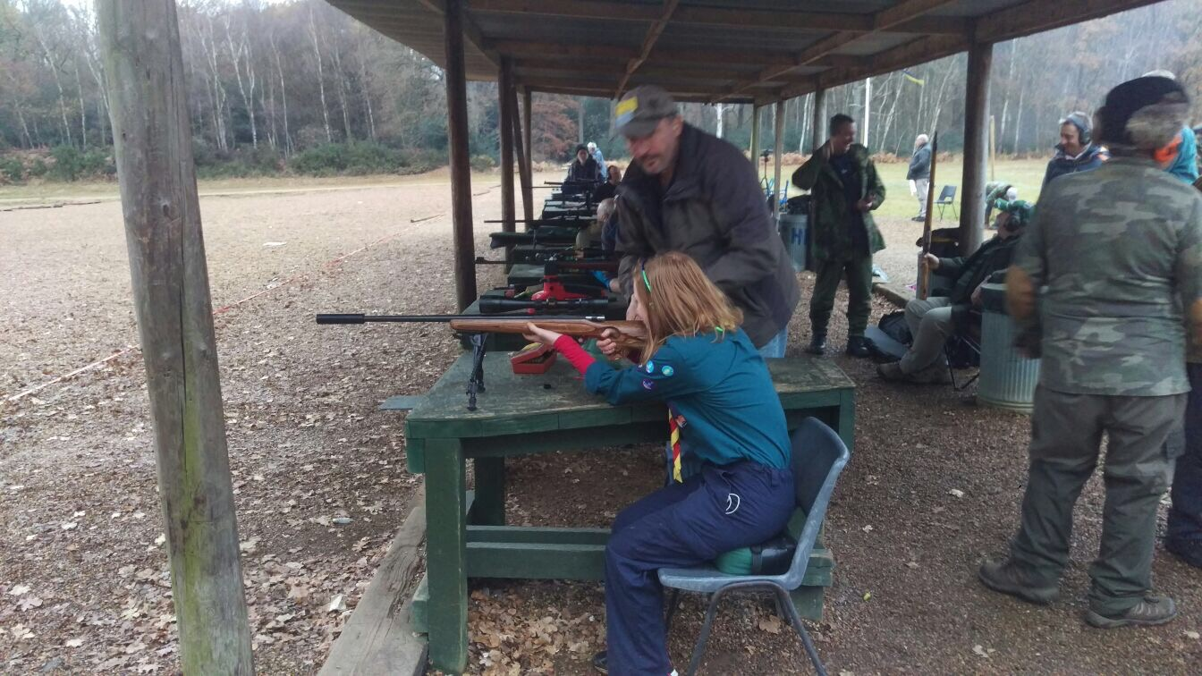

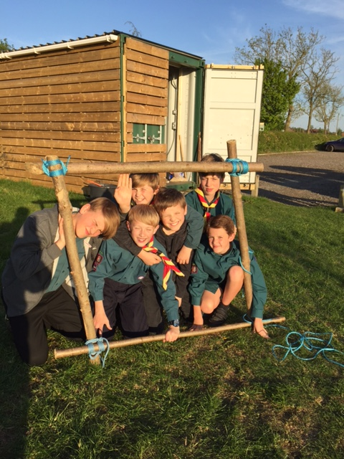
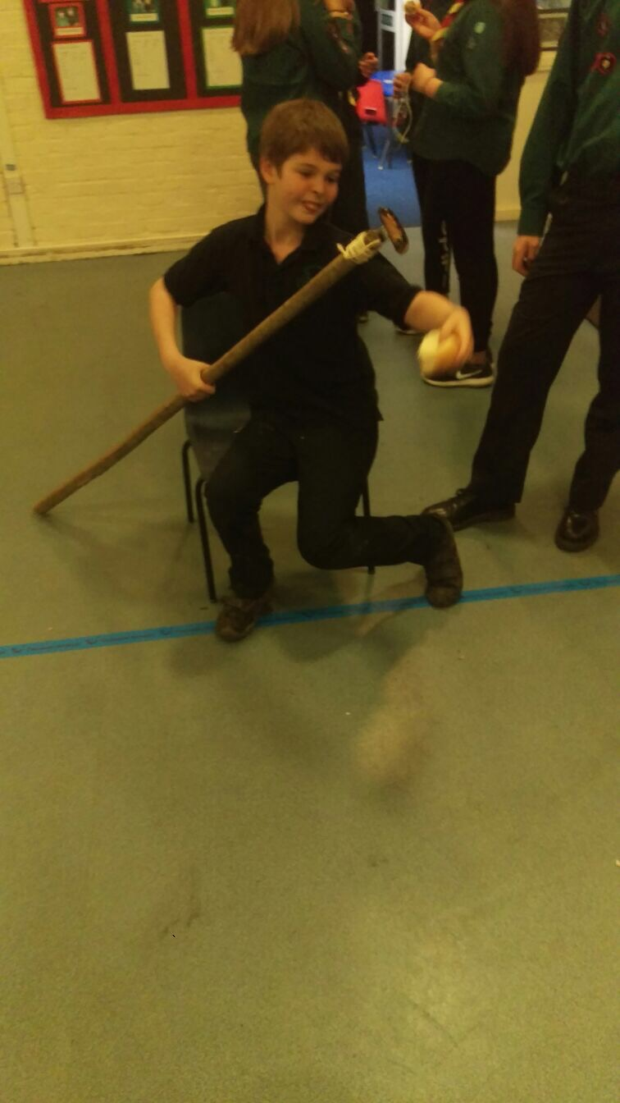

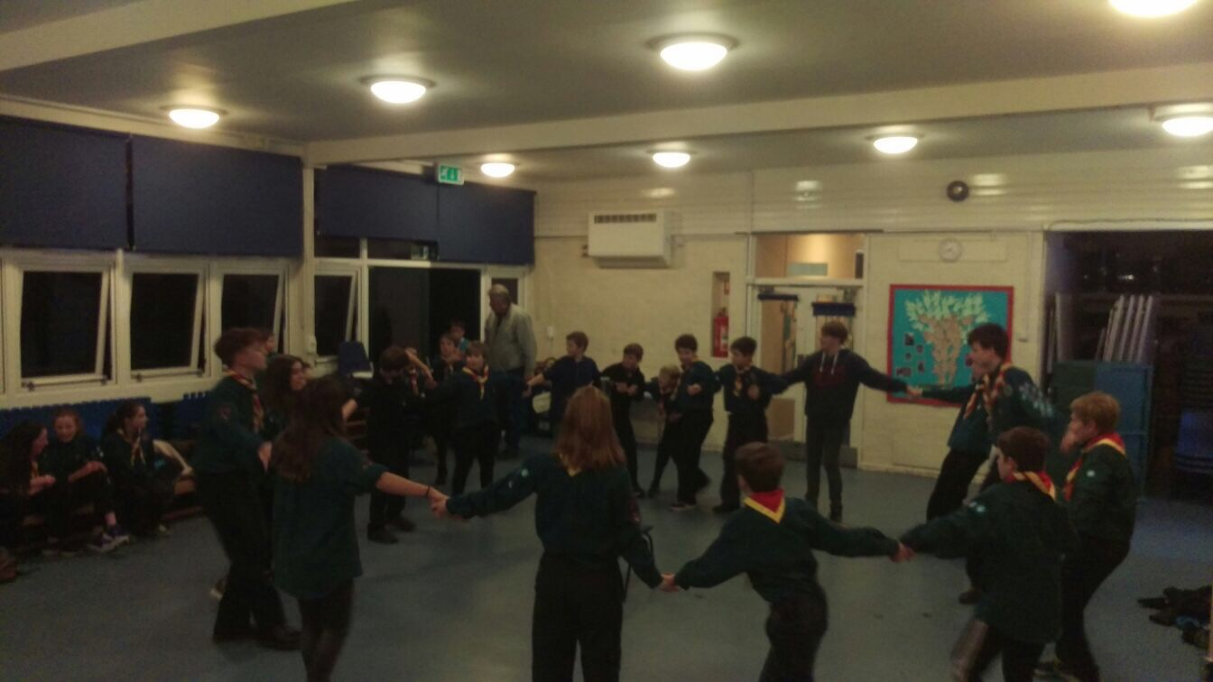

Mark Weedon (Group Scout Leader)
On behalf of
The Executive Committee 1st Granborough Scout Group

