**SCHORNE TEAM OF PARISHES**



A thought provoking film on the first Wednesday of every month

4th APRIL

YOU’RE NEVER AS ALONE AS YOU THINK

THE

SHACK

**A grieving man receives a mysterious, personal invitation to meet with God at ‘The Shack’**

|  |  |  |
| --- | --- | --- |
| *Sam WORTHINGTON* | *Octavia SPENCER* | *Tim McGRAW* |

Doors open and sweets and soft drinks available from 7.15pm – film starts at 7.30pm

Wesley Centre, Schorne Lane, North Marston MK18 3PJ – admission free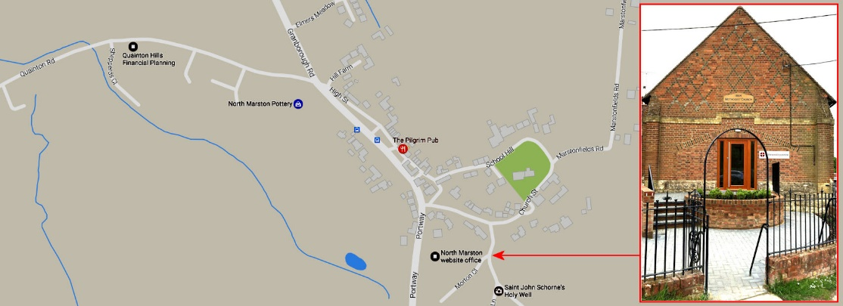

**SCHORNE TEAM OF PARISHES**



A thought provoking film on the first Wednesday of every month

4th APRIL

YOU’RE NEVER AS ALONE AS YOU THINK

THE

SHACK

**A grieving man receives a mysterious, personal invitation to meet with God at ‘The Shack’**

|  |  |  |
| --- | --- | --- |
| *Sam WORTHINGTON* | *Octavia SPENCER* | *Tim McGRAW* |

Doors open and sweets and soft drinks available from 7.15pm – film starts at 7.30pm

Wesley Centre, Schorne Lane, North Marston MK18 3PJ – admission free