SCHORNE TEAM OF PARISHES

A thought provoking film on the first Wednesday of every month
6th JUNE

A father is challenged by his son’s claim to have visited Heaven.
starring
Greg  KINNEAR | Kelly  REILLY | Thomas  HADEN CHURCH
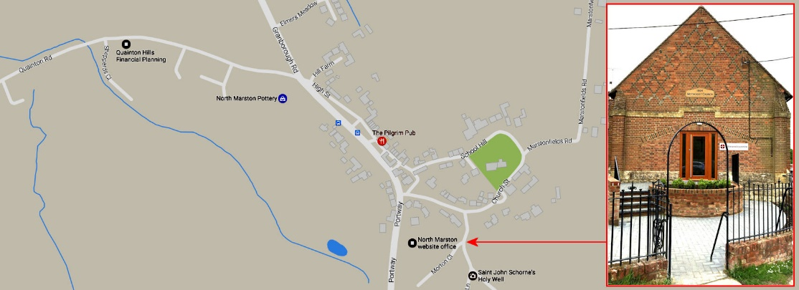
Doors open and sweets and soft drinks available from 7.15pm – film starts at 7.30pm
Wesley Centre, Schorne Lane, North Marston MK18 3PJ – admission free

