SCHORNE TEAM OF PARISHES

Wesley Flics is taking a break in October and November
Our next screening will be on
Wednesday 5th December
when we will be showing
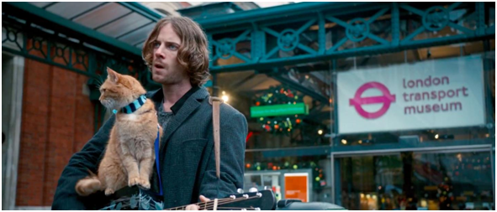

When a London busker and recovering drug addict finds an injured ginger street cat he has no idea just how much his life is about to change.
Staring Luke Treadaway

Doors open and sweets and soft drinks available from 7.15pm
Film starts at 7.30pm

Wesley Centre, Schorne Lane, North Marston MK18 3PJ
Admission free

