REVISED SERVICES FOR NOVEMBER

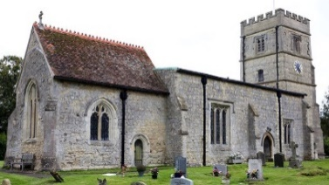
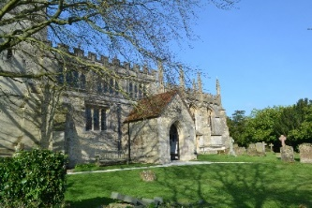

St Mary’s Church, North Marston and
St John the Baptist Church, Granborough

IT IS WITH REGRET THAT WE ANNOUNCE THAT WE WILL NOT BE OPEN FOR SERVICES FOR THE DURATION OF THE CURRENT LOCKDOWN

The revised programme of services for the remainder of November, and early December is:
St Mary’s Church, North Marston
Sunday 8th November: Zoom Remembrance Service at 10.30am.
Sunday 15th November: Zoom Service at 10.30am, immediately followed by the APCM (Annual Parish Council Meeting), starting approximately at 11.30am. Please join us at this meeting if you can.
Sunday 22nd November: Sunday Reflections only.
Sunday 29th November: Zoom Advent Family Service at 10.30am.
Sunday 6th December: Zoom Christingle Service at 4.00pm (for details, see separate poster in the magazine).

St John the Baptist Church, Granborough
Sunday 8th November: Remembrance Service at 10.45am.
Sunday 15th November: Zoom Service at 10.30am.
Sunday 22nd November: Zoom Service at 10.30am.
Sunday 29th November: Zoom Advent Family Service at 10.30 am.
Sunday 6th December: Zoom Christingle Service at 4.00pm (for details, see separate poster in the magazine).
If you have not joined a Zoom service before, and would like to, please approach Petra directly by email, and she will send you the link in advance.

