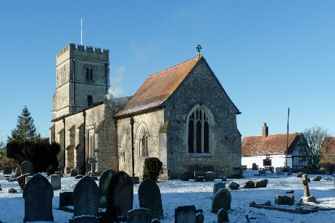
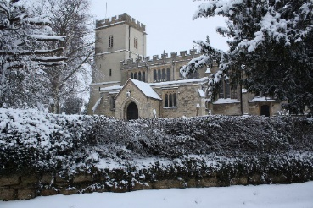

St Mary’s Church, North Marston and
St John the Baptist Church, Granborough – Notices for January
IMPORTANT UPDATE!
Whilst Government guidelines allow services in churches, the Oxford Diocese has advised us to think very carefully about our individual circumstances, and in our decision-making put the safety of our congregations first. We look forward to a return to a combination of Zoom and face-to-face services in our individual churches, but for the time being, we will be moving to online services only.
The revised programme of services for January is:
Sunday 3rd January: Shared Zoom Family Service at 10.30am.
Sunday 10th January: Sunday Reflections
Sunday 17th January: Shared Zoom Communion Service at 10.30am.
Sunday 24th January: Sunday Reflections
Sunday 31st January: Shared Zoom Family Service at 10.30am.

If you have not joined a Zoom service before, and would like to, please approach Petra directly by email, and she will send you the link in advance (petra.elsmore@gmail.com)

Clergy
Rev Petra Elsmore: 07557045703 petra.elsmore@gmail.com
Rev Janet Bayly: 670245 janet.bayly@gmail.com
Churchwardens North Marston:
Aly Perrett 670302 alysonperrett3@gmail.com
Tricia McSweeney: 670484 tricia.mcsweeney@btinternet.com
Churchwardens Granborough
Peter Evans 670570 petergranborough@gmail.com
Robert Kemp 670204 rookery4@aol.com

