ST MARY’S NORTH MARSTON
HARVEST FESTIVAL

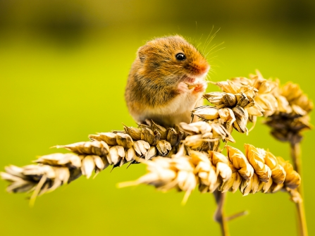
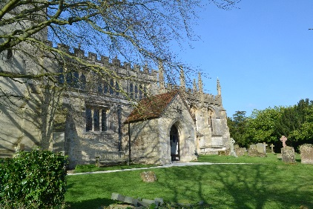

Sunday 3rd October 11.00am
Season of mists and mellow fruitfulness… (John Keats)

The Harvest Festival Service is always a very special family event in the Church Calendar and this year will be no exception, as it will be a wonderful opportunity to celebrate our return to Church after the long periods of lockdown. St Mary’s Church will be decorated especially for the occasion. The service will be led by David Heffer and young people of North Marston, beginning at 11.00am. Donations of non-perishable foods will go to support the Trussell Trust Food Bank in Aylesbury. A lively auction of donated perishable food will follow the service in Church, so please come along prepared to bid!

We will then move to the Churchyard or the Wesley Centre, depending on the weather, for a Picnic Lunch at about 12.30pm. As we still remain cautious, you are invited to bring along your own picnic, picnic rug etc. Drinks will be provided by the Church. The Service and picnic are open to everyone, especially children, and you can be assured of a very warm welcome.

We plough the fields and scatter the good seed on the land
But it is fed and watered by God’s Almighty hand …….

