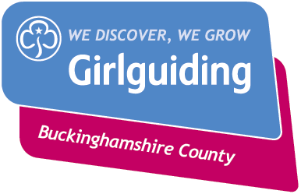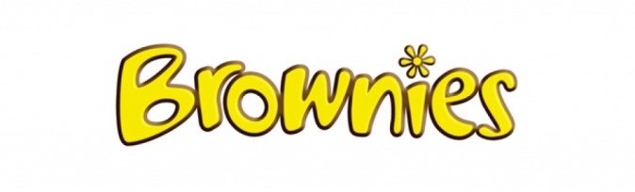

1st North Marston Brownie Unit
A new Brownie unit will be opening in North Marston on Monday 6th March 2017, meeting at the Wesley centre in North Marston, 6.15pm til 7.45pm.
Contact Tricia McSweeney (Brown Owl) 670484 or Hannah Goss 670504 for details and to register your daughter.
Brownies is for girls aged 7 to 11. Girls in Brownies have incredible experiences together, make brilliant friends and discover the world around them. Every time they meet up, groups of Brownies learn new skills and take on challenges as they work out what they want to be and do in the future.
Girls follow the Brownie Adventure programme in their regular meetings. They work towards interest badges related to activities and skills

