SCHORNE TEAM OF PARISHES

A thought provoking film on the first Wednesday of every month
5th SEPTEMBER
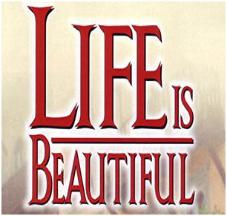
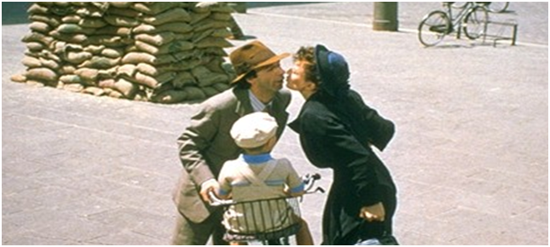

An inspired, award winning story about the power of love and the human spirit
starring

Roberto BENIGNI | Nicoletta BRASCHI | Giorgio CANTARINI
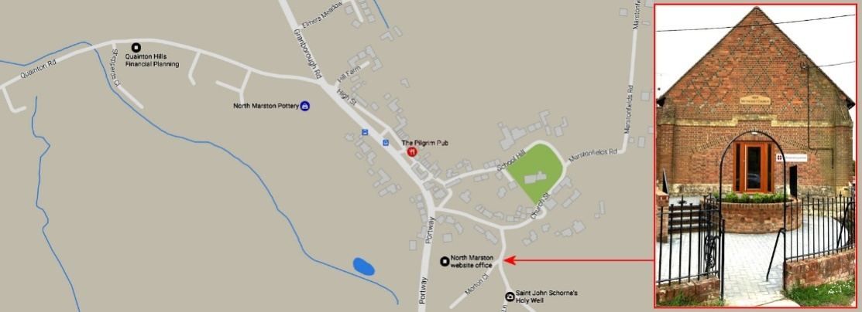
Doors open and sweets and soft drinks available from 7.15pm – film starts at 7.30pm
Wesley Centre, Schorne Lane, North Marston MK18 3PJ – Admission free

