Unitary, HS2, OxCam Bypass, and VALP updates

Unitary Council

On the 2nd of April the Structural Changes Order was laid before Parliament.
This is the second piece of legislation required to implement the new unitary council for Buckinghamshire and follows on from the Regulations that were agreed earlier this year.
The Structural Changes Order details how the change to the new council will take place and the set-up of the new council. The draft Order will be considered and debated by both Houses of Parliament, and confirms the following details:
· The name of the new council will be ‘Buckinghamshire Council’ and it will have 147 councillors.
· Elections for the new council will take place in May 2020.
· A temporary Shadow Authority will be formed, with all current county and district councillors having a seat on this body; the Shadow Authority will set the 2020/21 council tax and budget.
· Leadership will be provided by a 17-seat Shadow Executive with the Leader of Bucks County Council as its chairman.
· An implementation team, led by the Bucks County Council Chief Executive and with a district Chief Executive as deputy, should be established to manage the smooth transfer of services and staff to the new council.
It is expected that the Order will take around 6 to 8 weeks to progress through Parliament. Once it is approved the Shadow Authority then needs to meet within 14 days.

It’s now only one year to go to the new council - and there has been good progress over the last few months behind the scenes to prepare. The unitary programme structure including new management and governance arrangements are being put in place to help us prepare and manage the work to move from five councils to one. With 12 months to go it is critical that we use our collective knowledge and expertise to create the new council bringing together colleagues from across all our organisations and I’m encouraged by the collective effort of staff from across all the councils in working together on this. Karen Jones from Aylesbury Vale District Council and Roger Goodes from Bucks County Council have been appointed as the Unitary Programme Managers to coordinate the huge amount of work that will be taking place over the next year. It is important that the programme reflects both district and county perspectives wherever possible, so it’s great to see this already taking effect in these roles. Further appointments to the programme office from across the councils are being made soon.

To support the delivery of the unitary programme, there will be three programme boards established and co-chaired by both county and district colleagues. Each board will coordinate relevant work-streams looking at the detailed areas of work that need to be carried out and delivered to make this a seamless transition on 1 April 2020. In addition there are two further boards which are already in existence relating to Adult Social Care and Children’s Social Care. Both of these boards are focused on improving services and include a number of key partners.

The boards and their chairs are as follows:
Unitary Programme Boards
Resources Board | John McMillan, Wycombe District Council and Sarah Ashmead, Buckinghamshire County Council
Communities Board | Steve Bambrick, Chiltern and South Bucks District Council and Gill Quinton, Buckinghamshire County Council
Housing, Growth and Economy | Tracey Aldworth, Aylesbury Vale District Council and Neil Gibson, Buckinghamshire County Council
Continuing Improvement Boards
Children’s Board | Tolis Vouyioukas, Director of Children’s Services (BCC) and partners
Adults Board | Gill Quinton, Director of Adults Services (BCC) and partners

The chairs of these boards will attend regular meetings with the Chief Executives. This meeting will be the Chief Executives’ Implementation Group (CIG) and will ensure that work is progressed and papers produced for the meeting of our political Interim Shadow Executive.

The Interim Shadow Executive group is an informal meeting of members from across the five councils. I’m pleased that we now have been able to bring together the members across the five councils and have held our first meeting to begin discussion on how we will come together over the next year and we will continue to meet over the coming months.

Whilst we are waiting for the Structural Changes Order to be passed through Parliament this group will meet informally as the Interim Shadow Executive.

You may have also heard that the application for a Judicial Review from our three southern district councils has been refused by the courts. Chiltern and South Bucks District Councils have also confirmed they will not be taking this application any further.

HS2

As part of the collective action, Aylesbury Vale and Chiltern District Councils have already debated and agreed a special motion calling on the Government to pause all current site work until the 'Notice to Proceed' has been approved.

As required by the Department of Transport, a Notice to Proceed should not be given until the management capability, affordability of contracts and robustness of the revised business case have all been fully proven and approved.

In a joint statement, Council Leaders said "There was absolutely no justification why the County's residents should suffer significant disruption and long term environmental destruction while things remain so unclear.

OxCam Bypass

Although we have had knowledge of the ‘preferred route’ for quite some time, no further developments or indications regarding the specifics of the route have been disclosed by central government. Apart from a report from the Campaign to Protect Rural England (CPRE), there has been little noise on the issue.

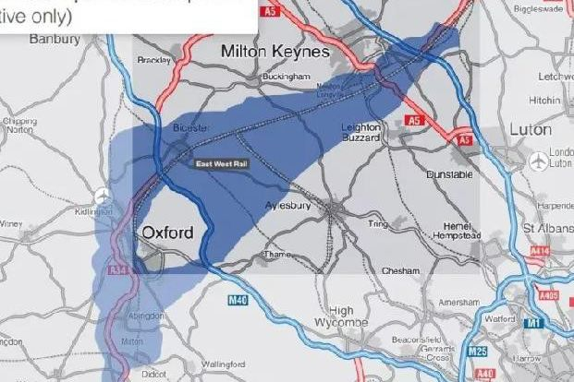
The government’s preferred route

In an interview in March 2018, Sajid Javid, the housing secretary, said that he would give the go-ahead to at least two new towns along the corridor "in the next few weeks" and could push for up to three more. As of yet, these announcements have not materialised.

Public consultations on the route are due to begin as soon as the route has been chosen.

VALP

The independent Planning Inspector has agreed AVDC’s proposal to reduce by 1400 the number of new homes to be built up to 2033 in the Vale of Aylesbury Local Plan (VALP).

The VALP is the blueprint that will shape the size and locations of housing and other developments over the next 14 years and beyond in the Aylesbury Vale. This latest development brings the end of a thorough and complicated process in sight, with modifications to the plan being considered by the Inspector and, it is hoped, a public consultation to follow this spring.

The full text of the Inspector’s response can be viewed at www.aylesburyvaledc.gov.uk/inspectors-interim-findings

The biggest change that the Inspector has agreed is to reduce the numbers of homes that need to be built within the Vale to 30,100 homes from the 31,500 he asked for previously. AVDC is working on the detailed modifications to VALP, which involves gathering a significant amount of new evidence and revising large numbers of policies. When these alterations have been made and sent to the Inspector, AVDC hopes to quickly put in place a six-week public consultation. The council hopes that the plan will then be adopted for use by mid 2019, although this depends on the Planning Inspector.

The adoption of VALP will not be affected by the creation of the new unitary council.

