North Marston & Granborough
Community Sports Field
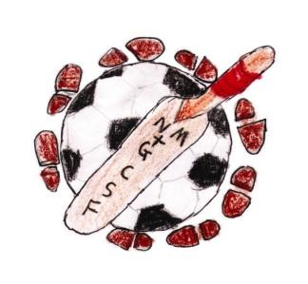

NORTH MARSTON AND GRANBOROUGH COMMUNITY SPORTSFIELD
UPDATE – MAY 2020

The Sportsfield continues to provide a valuable and well used space for residents to use as a facility for their recreation, particularly so right now as we are all restricted in our lives due to the coronavirus pandemic.

Junior Football

The football season was cut short due to the coronavirus. Until the end of February
the Club continued its success with teams in the Milton Keynes District Development League from ages 7 to 17. Matches are played on Saturdays with multiple matches sometimes being played simultaneously on all three pitches.

Junior Cricket

Indoor nets took place at the Sir Thomas Freemantle school during February and the four sessions were well attended.
Sadly, in common with all cricket clubs, no cricket has been played so far this summer. Three teams were entered into the league in February at age groups U11, U13 & U15. The U9 also have a team which do not play in league cricket.
The U15s represents an opportunity for juniors to step up to senior cricket soon. Each junior team has its own dedicated team of Coach, Manager and Scorers.

Senior Cricket

The Senior Cricket Team have a full programme of Sunday fixtures for the 2020 summer. It is hoped that some matches can be played later in the summer, depending on government guidelines at the time.

Outfield

The summer of 2019 was more conducive to sport than the previous summer when the ground cracked to such an extent that sport was seriously impacted and, in some cases, games cancelled.
The field is in good shape but at present can only be used for general recreation with no team sports or groups gathering permitted due to government restrictions.

Public Use

The public have free use of the field when it is not being used by the organised clubs. It is regularly frequented by walkers (with or without dogs), runners, children playing ball games and those who utilise the space for specific exercise or training.

Nature Trail

The Nature Trail continued to be used by the village school for its Forest Schools activities and by the general public until the end of February. The committee now has a specific member who liaises with BBOWT and other wildlife organisations for advice, support, and resources.
Over the winter, areas were cleared within the Nature Trail and hedges cut back. This made the area far more user friendly. Wildflower seeds were sown in various places and we hope to see the rewards of this during the summer.

Fundraising

A combination of North Marston and Granborough PC funds granted last year will be used for:
- New signage
- CCTV cameras
- A path to link clubhouse and machinery store.

The Sportsfield committee will endeavour to continue to maintain and to further improve the facility for the benefit of the community and all other users. All maintenance requires funds and the committee are always looking for new ideas and volunteers to help with this.

The Sportsfield Committee is very grateful to the Parish Councils of both Granborough and North Marston for their continued support.

On behalf of the Sportsfield Committee

Trevor Lane (Chair), Pete Butler (Vice Chair), Andy Keegan (Treasurer), Gordon Bowden, Barry Kirwan, Ian Mordue, James Radcliffe, Trevor Jenkins.

