North Marston Neighbourhood Plan
Basic Conditions Statement

April 2022

Table of Contents
1. Introduction 2
Figure 1: Map showing extent of Neighbourhood Planning Area 3
2. Background 4
3. Conformity with National Planning Policy 4
Table 1: NPPF Conformity 5
4. Contribution to Sustainable Development 6
Table 2: Sustainability Attributes 7
5. General Conformity with Strategic Local Policy 9
Table 3: Conformity with VALP Policies 9
6. Compatibility with EU Legislation 11
Table 5: Human Rights 12
7. Conclusion 12

Introduction
  - This Statement has been prepared by North Marston Parish Council (NMPC) to accompany the North Marston Neighbourhood Plan 2020-2035 (Submission Version April 2022) on submission to Buckinghamshire Council (BC) under regulation 15 of the Neighbourhood Planning (General) Regulations 2012 as amended (“the Regulations”).
  - The Neighbourhood Plan has been prepared for the Neighbourhood Area covering the whole of the Parish, as designated by Aylesbury Vale District Council (now Buckinghamshire Council) on 25th May 2018. (Figure 1 below).
  - The policies described in the Neighbourhood Plan relate to the development and use of land in the designated Neighbourhood Area and do not relate to any other designated Neighbourhood Area. The plan period is from 1st April 2020 to 31st March 2035.
  - The Neighbourhood Plan does not contain policies relating to excluded development in accordance with the Regulations. The document also contains a number of non-statutory proposals that relate to Aspirations which do not form part of the examined ‘neighbourhood development plan’ but provide a ‘wish list’ that has emerged during consultation that the Parish Council has considered during the preparation of the document.
  - The Statement addresses each of the four ‘basic conditions’ required of the Regulations and explains how the submitted Neighbourhood Plan meets the requirements of paragraph 8 of schedule 4B to the Town and Country Planning Act 1990.
  - The Regulations state that a Neighbourhood Plan will be considered to have met the basic conditions if:
    - Having regard to National Policies and advice contained in guidance issued by the Secretary of State, it is appropriate to make the neighbourhood development plan
    - The making of the neighbourhood development plan contributes to the achievement of sustainable development
    - The making of the neighbourhood development plan is in general conformity with the strategic policies contained in the development plan for the area of the authority (or any part of that area)
    - The making of the neighbourhood development plan does not breach, and is otherwise compatible with EU obligations

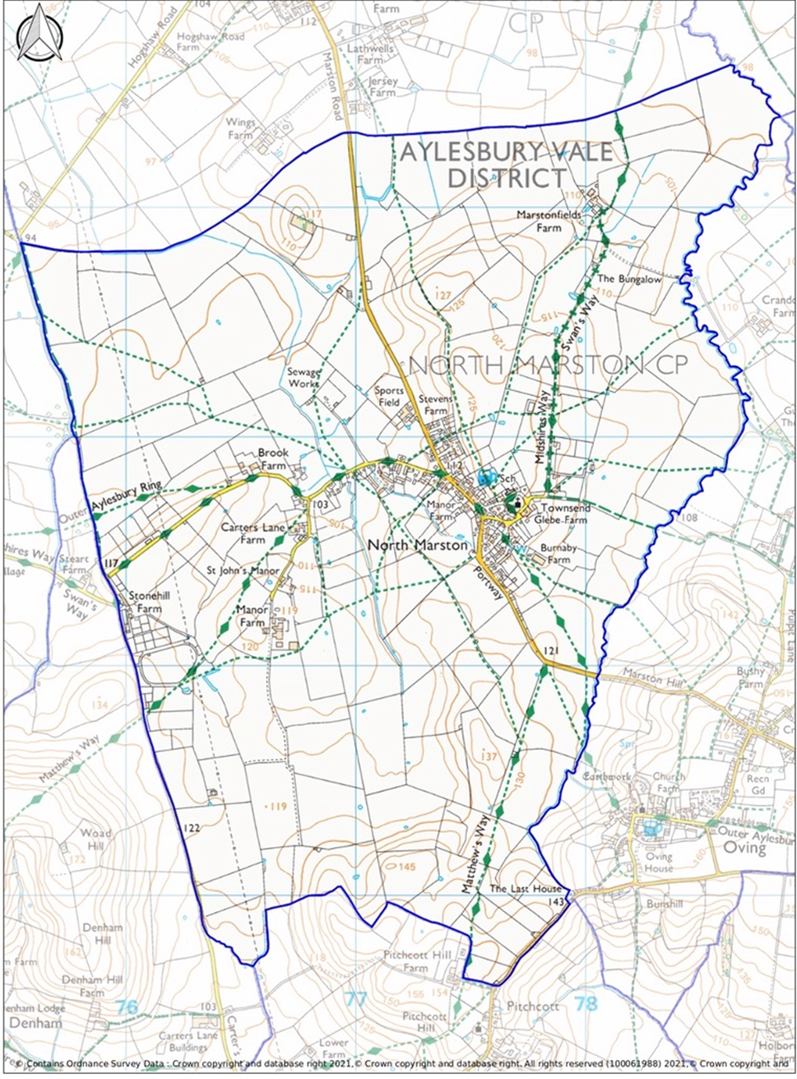

Figure 1: Map showing extent of Neighbourhood Planning Area

Background

  - The plan preparation has been led by NMPC, through the Neighbourhood Plan Steering Group. It has comprised three main stages:
- Evidence gathering and community engagement which has been incorporated into the Neighbourhood Plan,
- Pre-Submission Neighbourhood Plan December 2021 (Consultation Draft version); the draft plan and accompanying background documents were published for more than 6 weeks in accordance with regulation 14 of the Regulations,
- Submission Neighbourhood Plan (April 2022) which takes into account representations received on the earlier version and has been modified for submission to BC; it is accompanied by the Basic Conditions Statement, the Design Code, and the Consultation Report.
  - NMPC has consulted the local community extensively throughout the process.
  - The NMPC website https://northmarston.org/ has been used throughout the process to disseminate information and publicise consultations. A number of methods to raise awareness have been used, including banners, flyers, and notices on the Parish Council noticeboards.
  - The Draft Neighbourhood Plan was formally consulted upon from 15th December 2021 to 9th February 2022. Full details are set out in the Consultation Report.
  - NMPC has also worked closely with officers of BC since the start of the project to collate and examine the evidence base, to design and iterate policy proposals and to define the proper relationship between the Neighbourhood Plan and the emerging Local Plan (now adopted).
  - The Plan has not duplicated Local Plan policies which will be used in determining planning applications. This has allowed the Neighbourhood Plan to focus on a smaller number of locally relevant and important policies.

Conformity with National Planning Policy

  - The Neighbourhood Plan has been prepared with regard to national policies as set out in the National Planning Policy Framework 2012 (NPPF) and the revised Framework of July 2021 and is mindful of the National Planning Practice Guidance (NPPG) in respect of formulating neighbourhood plans.
  - There are several NPPF paragraphs that provide general guidance on neighbourhood planning, to which the Neighbourhood Plan has directly responded.
  - In relation to the presumption in favour of sustainable development:
    - Paragraph 12: the development plan is the starting point for decision making and this includes any neighbourhood plan.
    - Paragraph 13: neighbourhood plans should support the delivery of strategic policies contained in local plans or spatial development strategies and should shape and direct development that is outside these strategic policies.
    - Paragraph 14: reminds us of the adverse impact of allowing development that conflicts with the neighbourhood plan because such development is likely to significantly and demonstrably outweigh the benefits provided. Four criteria apply.
  - The Parish Council believes that the Neighbourhood Plan is planning positively for future development in the parishes and supports the delivery of the strategic policies of the adopted Development Plans as advised in the above paragraphs of the NPPF.
  - Paragraphs 18 and 21 advise that policies to address non-strategic matters and detailed matters should be included within neighbourhood plans, and the Neighbourhood Plan contains such policies.
  - Advice on non-strategic policies and the role of neighbourhood plans is identified in paragraphs 29 and 30. The Neighbourhood Plan establishes a shared vision for the area, and its policies shape, direct, and help to deliver sustainable development. It has sought to translate objectives into a number of meaningful planning policies to complement other development plan policies for managing development.
  - The Neighbourhood Plan strikes a positive balance between the policy constraints of the Parish and the need to support the general requirements of the development plan as set out in section 5 below.
  - The Neighbourhood Plan avoids duplicating development plan policies by focusing on policies that translate the general requirements of the development plan into a local context. Once made, the Neighbourhood Plan should be easily considered alongside the development plan and any other material considerations in determining planning applications.
  - Set out below is a brief summary of how each policy conforms to the NPPF. The particular paragraphs referred to in the table are those considered the most relevant to each policy but are not intended to be an exhaustive list of all possible relevant paragraphs.

Table 1: NPPF Conformity
Policy | Policy Title | NPPF Para no. | Commentary
E1 | Rural Character | 126, 127, 130, 174, 175 | Sets the context for new development to ensure rural character is retained.
E2 | North Marston Conservation Area and its setting | 130, 189, 190,  191, 194, 195, 199, 201, 207 | Seeks to emphasise the importance of high-quality design and development in and close to the Conservation Area.
E3 | Protecting and enhancing local heritage assets | 189, 195, 199, 201, 203 | Seeks to conserve and protect non-designated historic assets and their setting.
E4 | Field patterns and archaeology | 190, 192, 194, 195, 197, 199, 205 | Seeks to prevent loss or mitigate against any damage to archaeology including the nationally important ridge and furrow in the Parish.
NE1 | Protecting the Landscape | 126, 127, 130 174 | The landscape features and setting of the settlement in the Parish is very important in the context of NPPF policies which seek to ensure development contributes to and enhances the natural environment.
NE2 | Biodiversity | 174, 175, 179, 180 | New development is expected to retain natural features, provide 10% net gain in biodiversity, protect or replant black poplars, and plant new landscaping.
SD1 | Development within the Settlement Boundary | 78, 79, 84, 85, 93 | The emphasis on supporting new development within the Settlement Boundary is consistent with NPPF policies.
SD2 | New Housing Development | 78, 79, 126 | Requires a mix and variety of housing for all new development over 2 dwellings, including smaller units.
SD3 | High Quality Design | 92, 126, 127, 129, 130 | This policy seeks high quality sustainable design for new development which respects the character of the village and conforms to the parish Design Code.
SD4 | Provision of energy efficient buildings | 152, 154, 157, | Requires a high level of sustainable design and construction.
SD5 | Water management | 161, 167 | The policy seeks to reduce flood risk and run-off, incorporate SUDS, and be water efficient.
C1 | Community facilities | 84, 92, 93 | Retains specific community facilities and encourages new facilities.
C2 | Local green spaces | 98, 99, 101, 102, 103 | Designates Local Green Spaces in line with the criteria set out in the NPPF.
C3 | Supporting Local Employment and Agriculture | 84, 85 | Encourages the expansion and development of small businesses and homeworking subject to impact.
TT1 | Car parking | 104, 106, 110, 112 | Supports parking for new developments including charging points and seeks to retain public parking.
TT2 | Provision for pedestrians, cyclists, and horse riders | 100, 104, 106, 112 | The policy seeks to improve/provide traffic calming, connectivity, and access with encouragement for additional rights of way and safe routes for pedestrians and cyclists. Requires new development to manage traffic and ensure new traffic related infrastructure is appropriate to the rural character.

Contribution to Sustainable Development

  - Buckinghamshire Council has determined that a Strategic Environmental Assessment (SEA) and a Habitats Regulations Assessment (HRA) was not required for the Neighbourhood Plan as it considered the policies were unlikely to have a significant environmental effect, as defined by the Environmental Assessment of Plans and Programmes Regulations 2004. The report is dated November 2021.
  - However, the basic condition of “contributing to the achievement of sustainable development” requires a broader scope of assessment to embrace social and economic as well as environmental objectives. For completeness therefore, Table 2 summarises the economic, social, and environmental attributes of each policy.
  - The vision and objectives of the Neighbourhood Plan comprise a balance of social, economic, and environmental goals. The social goals are to retain and encourage the local facilities and require a mix of new homes for the local community. Economic goals are relatively limited in scale in the Parish, but the provision of local business and agriculture is recognised. Environmental goals include the protection and enhancement of the area’s natural and historic environment.
  - However, the objectives make clear that there are environmental parameters within which these social and economic goals must be kept by ensuring development is in scale with the rural character of the existing parish.
  - The chosen policies therefore translate the objectives of the Neighbourhood Plan into viable and effective development management policies which will deliver strong social, economic, and environmental impacts.
  - The sustainability attributes of each policy are summarised in the table below.

Table 2: Sustainability Attributes
Key: *positive - neutral x negative
Policy | Policy Title | Soc | Econ | Env | Commentary
E1 | Rural Character | * | * | * | Ensures rural character is retained which is beneficial to both the environment and the wellbeing of residents. There is a minimal economic positive impact because the policy allows for appropriate development.
E2 | North Marston Conservation Area and its setting | * | - | * | This policy will deliver a very positive impact on the historic environment and enhance the wellbeing of residents through sympathetic design.
E3 | Protecting and enhancing local heritage assets | * | - | * | This policy will deliver a very positive impact on the historic environment and enhance the wellbeing of residents through sympathetic design.
E4 | Field patterns and archaeology | * | X | * | This policy will deliver a very positive impact on the historic environment and enhance the wellbeing of residents through sympathetic design. It could have a negative impact on economic issues by preventing or delaying development in the special areas.
NE1 | Protecting the Landscape | * | - | * | This policy ensures that the rural and historic character of the Parish landscape is retained, which is beneficial to both the environment and the wellbeing of residents
NE2 | Nature Conservation | * | - | * | This policy provides a positive impact for the natural environment and for the sense of place which can enhance the wellbeing of residents.
SD1 | Development within the Settlement Boundary | * | * | * | This policy is positive in all aspects, allowing sustainable development while maintaining the character of the village and promoting community uses/facilities.
SD2 | Housing | * | * | x | This policy may have a negative impact on the environment because it allows new housing. However, there are positive effects on social wellbeing by providing housing as well as economic benefits through construction and by bringing in additional residents who can support local facilities. A housing mix which reflects the needs of the village will bring positive social benefits by rebalancing the housing stock towards smaller homes.
SD3 | High Quality Design | * | * | * | In economic terms, this policy is only slightly positive because well designed places and buildings can ensure value is retained/increased, but it is positive in environmental and social terms. It seeks to ensure that important design and biodiversity features are retained and enhanced
SD4 | Provision of energy efficient buildings | * | x | * | Provision of energy efficient buildings is very good for the environment and also health. However, such homes can have a higher cost, especially if retrofitting, which could impact economically.
SD5 | Water Management | - | - | * | Managing water resources properly will have a very positive effect on the environment.
C1 | Community facilities | * | * | * | The retention and encouragement of community facilities will clearly be positive in terms of wellbeing and the social aspects of village life as well as retaining local businesses.
C2 | Local Green Spaces | * | - | * | This policy protects green spaces from being developed and therefore has a positive social and environmental impact
C3 | Supporting Local Employment and Agriculture | * | * | x | The retention and expansion of local businesses will clearly have a positive impact on economic factors and social factors but is potentially neutral or negative for the environment.
TT1 | Car Parking | * | x | * | Adequate provision of parking is good for residents who are dependent on cars in this location and has economic benefits. It is not positive for the environment as cars are not a sustainable form of transport.
TT2 | Provision for pedestrians, cyclists, and horse riders | * | X | * | Ensuring the traffic environment is safe for pedestrians and does not lead to inappropriate levels of traffic is both positive for the environment and for social goals. Economically the policy may have a negative impact as it would require additional investment in infrastructure. The provision of footpath and cycleways improve the health of residents and is a positive benefit for the environment, reducing pollution.

General Conformity with Strategic Local Policy

  - North Marston Parish lies within the local planning authority of the new Buckinghamshire Council, which was formed in April 2020. However, the most recent development plan was started by the former Local Authority for the area, which was Aylesbury Vale District Council. The Vale of Aylesbury Plan 2013-2033 (VALP) was adopted on the 15th September 2021.
  - The following table sets out the comparison of Neighbourhood Plan policies with policies from the VALP. Accordingly, the NMPC considers that the Neighbourhood Plan is in general conformity with the strategic policies of the Local Plan and the policies have been designed to add local context to the development plan policies of the area.

Table 3: Conformity with VALP Policies
NMNP Policy | Title | VALP Policies | Comments
E1 | Rural Character | BE2 | Design of new development.
E2 | North Marston Conservation Area and its setting | BE1, BE2 | NP policy is in line with VALP policies BE1 and BE2 by requiring the preservation and enhancement of the historic environment which may be achieved through good design.
E3 | Protecting and enhancing local heritage assets | BE1, BE2 | NP policy is in line with VALP policies BE1 and BE2 by requiring the preservation and enhancement of the historic environment which may be achieved through good design.
E4 | Field patterns and archaeology | BE1 | The NP policy is supporting the historic environment in the Parish and conforms with BE1.
NE1 | Protecting the Landscape | NE1, NE4, NE8 | Respecting landscape character and locally important landscape, trees, hedgerows, and woodlands are all consistent with VALP policies.
NE2 | Biodiversity | NE1, NE8 | Biodiversity net gain in the NP policy is in general conformity with VALP NE1, and with NE8 in respect of trees, hedgerows, and woodlands.
SD1 | Development within the Settlement Boundary | S2, D3, BE2 | VALP S2 allocates no sites for development due to the unsustainable nature of the medium village which is North Marston, although VALP policy does cover housing development at medium villages, by allowing infill and consolidation of settlement patterns. The designation of a settlement boundary in the NP is entirely consistent with the VALP approach, particularly bearing in mind the constraints at North Marston in terms of its historic character and landscape. Design of new development is a key issue and NP policy is consistent with BE2.
SD2 | New Housing Development | H6A | VALP policy H6A requires a mix of homes; the NP policy gives a more detailed interpretation of the VALP policy.
SD3 | High Quality Design | BE2 | Design of new development is a key issue and NP policy is consistent with BE2. It also requires development to adhere to the NM Design Code.
SD4 | Provision of energy efficient buildings | S1 | NP policy goes further than VALP S1, seeking to ensure that new buildings are energy efficient.
SD5 | Water management | I4, I5 | The management of water is an important issue for the Parish and NP policy reflects VALP I4 and I5
C1 | Community facilities | D7, I3 | The NP Policy strives to retain community facilities in line with VALP D7 and I3. These seek to prevent the loss of essential facilities, community buildings and businesses, while encouraging small scale new facilities.
C2 | Local green spaces | NE6 | The NP identifies LGS consistent with NPPF policy and Policy NE6 Local Green Space in VALP.
C3 | Supporting Local Employment and Agriculture | E4, E9 | E4 supports working at home and NP policy follows this, particularly as many residents of this Parish work from home and there is a valuable opportunity to provide additional services within the village. The NP also wishes to support agriculture in this rural Parish in line with the provisions of E9.
TT1 | Car parking | T6, T8 | VALP T6 refers to parking standards and the NP policy reinforces this and also refers to electric vehicle charging points (T8). These are particularly important in a rural Parish where residents are heavily reliant on cars.
TT2 | Provision for pedestrians, cyclists, and horse riders | T7, C4 | NP policy emphasises the need for pedestrian and cyclist safety on the rural network in line with T7 and protects rights of way (C4)

Compatibility with EU Legislation

  - Strategic Environmental Assessment. A formal screening opinion has been issued by BC, available to view on the Parish Council’s website at: https://northmarston.org/?page_id=2028 .
  - No SEA was required as set out in Section 5 of that report. The Council received a response from the Environment Agency, Historic England, and Natural England, the latter two noting that they agreed with the Council findings that the North Marston NP does not require a full SEA to be undertaken. The Neighbourhood Plan has accordingly been prepared in accordance with EU Directive 2001/42 on strategic environmental assessment (SEA).
  - Habitats Regulations. The Neighbourhood Area is around 18km from the Chilterns Beechwoods Special Area of Conservation (SAC). However, the scope of the Neighbourhood Plan, which does not allocate any sites for development, is not likely to exacerbate the vulnerabilities of the SAC. The screening was carried out by BC as a part of the SEA screening (see link above). Paragraph 6.1 of the report states that “The Neighbourhood Plan is not likely to lead to adverse effects on any European sites alone or in-combination. There is no requirement to prepare an appropriate assessment.” The Council received a response from the Environment Agency and Natural England, the latter noting that they agreed with the Council findings that the North Marston NP does not require a full SEA to be undertaken.
  - Human Rights. The Neighbourhood Plan has regard to the fundamental rights and freedoms guaranteed under the European Convention on Human Rights and complies with the Human Rights Act. The overall purpose of the Neighbourhood Plan is to improve the quality of life for people living and working now and in the future in the parish from an environmental, social, and economic point of view. The aims and policies in the Neighbourhood Plan have been formulated in response to local people’s views and in the light of evidence gathered for the parish, to meets the needs expressed and address the issues identified. In order to confirm that the NP does not have any unintended consequences for particular groups the strategic aims and the policies in the Plan have been systematically scrutinised to ensure that they do not disadvantage any potentially vulnerable groups. The Equality Act 2010 places a duty on all public authorities in the exercise of their functions to have regard to the need to eliminate discrimination, to advance equality of opportunity, and to foster good relations between persons who have a “protected characteristic” and those who do not. “Protected characteristics” are age, disability, gender reassignment, pregnancy and maternity, race, religion or belief, sex, and sexual orientation.
  - An assessment has been made on whether the policies in the Neighbourhood Plan have a positive, negative, or neutral impact on each of the protected characteristics.
  - Certain protected characteristics are not affected by the Neighbourhood Plan, namely gender reassignment, race, religion, or sexual orientation. For persons with these characteristics, the Plan has a neutral effect. Where policies in the Plan would adversely affect persons with these protected characteristics, they would not be differently affected than persons without these characteristics. For example, if a person with these protected characteristics were disadvantaged by a policy, it would have the same consequence for a person without the protected characteristic who wished to do the same thing. Similarly, if a person with one of these protected characteristics were to benefit from a policy, it would have the same benefit for a person without the protected characteristic in the same way.

Table 5: Human Rights
Policy | Policy Title | Outcomes for persons with certain protected characteristics
E1 | Rural Character | Neutral impact
E2 | North Marston Conservation Area and its Setting | Neutral impact
E3 | Protecting and enhancing local heritage assets | Neutral impact
E4 | Field Patterns and archaeology | Neutral impact
NE1 | Protecting the Landscape | Neutral impact
NE2 | Biodiversity | Neutral impact
SD1 | Development within the Settlement Boundary | Neutral Impact
SD2 | New Housing Development | Broadly positive impact
SD3 | High Quality Design | Broadly positive impact
SD4 | Provision of energy efficient buildings | Neutral impact
SD5 | Water Management | Neutral impact
C1 | Community facilities | Broadly positive impact
C2 | Local Green Spaces | Broadly positive impact
C3 | Supporting Local Employment and Agriculture | Broadly positive impact
TT1 | Car Parking | Neutral impact
TT2 | Provision for pedestrians, cyclists, and horse riders | Broadly positive impact

Conclusion

  - North Marston Neighbourhood Plan has been carefully prepared in accordance with the requirements of the Regulations and satisfies the Basic Conditions as set out in Paragraph 1.6 thereby contributing to the achievement of sustainable development.

