North Marston Neighbourhood Plan

2020 – 2035

Consultation Report

April 2022

# Foreword

1. North Marston Parish Council resolved in January 2018 to proceed with making a Neighbourhood Plan and the Neighbourhood Area was approved as being the whole of the Parish on 25th May 2018. A Steering Group was formed to produce the Neighbourhood Plan.
2. Since its formation, the Steering Group has tried to take every opportunity available to engage with the North Marston community despite the significant disruption to the Plan’s preparations resulting from the COVID-19 emergency.

## 

*North Marston Parish Boundary – the Neighbourhood Area*

# Introducing the Neighbourhood Plan concept to North Marston

1. Following the Group’s formation in April 2018, the concept of a North Marston Neighbourhood Plan was introduced to the community at two annual village events – the Annual Village Meeting and the Church Fete, held in May and June 2018.
2. At the Village Meeting the Neighbourhood Plan was introduced to all representatives of village organisations and youth leaders in a Question-and-Answer session which produced some useful initial indications of the priorities and concerns which would need to be considered.
3. The text of the introduction given by the Steering Group Chair at the Village Meeting in 2018 can be found here:

[www.northmarston.org/?page_id=858/NP Village Meeting Report 150518](http://www.northmarston.org/?page_id=858/NP%20Village%20Meeting%20Report%20150518)

1. At the Church Fete, which took place a short time after the Village Meeting and was attended by a wide cross-section of residents, a display was organised to explain the Neighbourhood Plan concept and introduce Group members. The Steering Group was available throughout the Fete to answer any questions and discuss the Plan.
2. The focus of the discussions with residents at the Church Fete was to assess and consider the areas of village life which were of most importance to residents in preparation for a future Open House which was advertised at the Fete, and at which Group members intended to go into more detail with residents about their concerns.
3. The display posters which were used at the Church Fete to introduce the Plan concept can be found here:

[www.northmarston.org/?page_id=858/Church Fete Presentation 2018](http://www.northmarston.org/?page_id=858/Church%20Fete%20Presentation%202018)

1. For those residents unable to attend either event, a further document was placed on the Parish Council website entitled “Introducing the North Marston Neighbourhood Plan”:

[www.northmarston.org/?page_id=858/INTRODUCING THE NORTH MARSTON NEIGHBOURHOOD PLAN](http://www.northmarston.org/?page_id=858/INTRODUCING%20THE%20NORTH%20MARSTON%20NEIGHBOURHOOD%20PLAN)

# Open House

1. Within a month of the Church Fete, in July 2018, the Steering Group held an Open House in the Memorial Hall which was devised as an opportunity for all members of the community to make their individual views known anonymously, and so provide the Group with more detailed information to use when producing a Parish Questionnaire.
2. The Open House was advertised widely in North Marston, with leaflets being distributed to every household as well as being displayed prominently on all noticeboards and public spaces in the village. Advertisements were also placed in the Village Magazine and online.
3. The leaflet distributed to all households can be found here:

[www.northmarston.org/?page_id=858/Open House flyer July 2018](http://www.northmarston.org/?page_id=858/Open%20House%20flyer%20July%202018)

1. In order to simplify matters yet at the same time gather as much information as possible, attendees were asked to consider three questions which had been formulated by the Steering Group following their discussions with residents:

* What do you like best about living here?
* What are your biggest concerns at the moment and for the future?
* What progress and changes would you like to see in the future?

1. Everyone who attended the Open House was encouraged to post written responses to each of these questions on notes attached to the appropriate whiteboard.
2. In an attempt to discover whether there were specific matters or opinions particularly relevant to different areas of the parish, responses were divided by asking residents from the different streets in the village to record their replies on appropriate colour-coded notes.
3. The Open House was attended by over 70 residents from all around the parish, and over 200 responses were posted. A map was displayed on which participants were asked to show the position of their homes so that the Group could ensure that responses did come from throughout the village.
4. The responses were carefully analysed by Group members and summarised in a published report. This analysis became a key source for the focused and detailed Parish Questionnaire, which was produced as the next, and most important, stage in the Plan’s development.
5. The analysis of responses at the Open House can be found here:

[www.northmarston.org/?page_id=858/Results of Open House July 7 2018 (1)](http://www.northmarston.org/?page_id=858/Results%20of%20Open%20House%20July%207%202018%20(1))

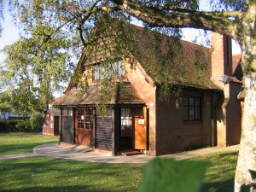

*Pictures from the Steering Group Open House held at the Memorial Hall on July 7th, 2018*

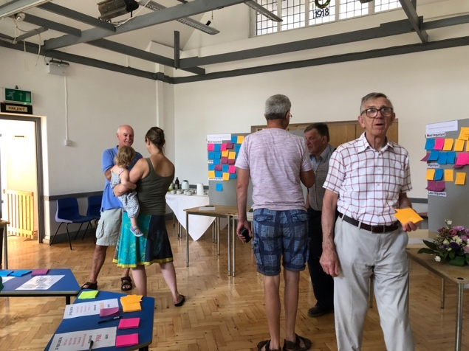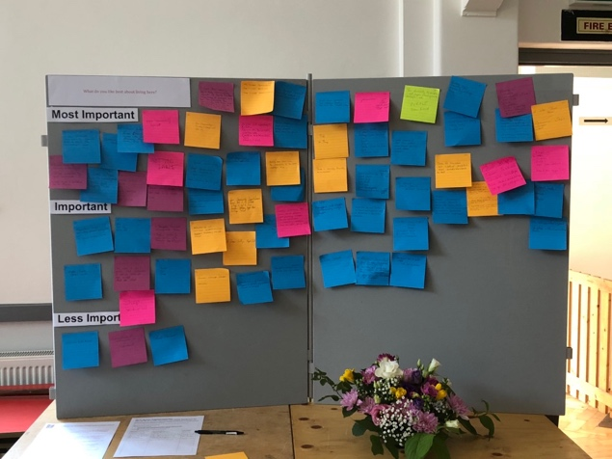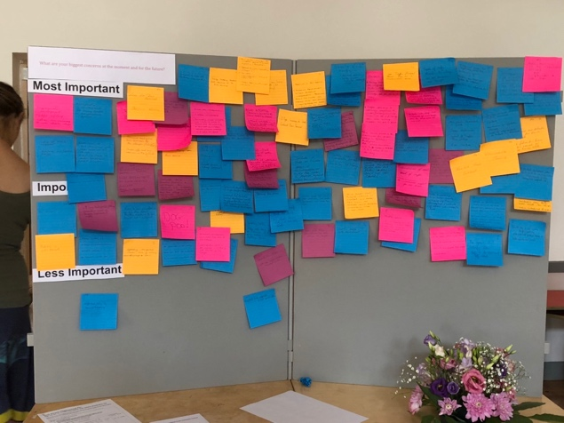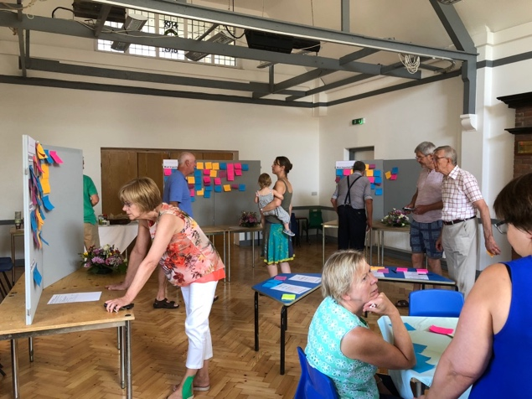

# Parish Questionnaire

1. After considering all the information gathered at these 3 public events, a comprehensive Parish Questionnaire was prepared to give every resident the chance to provide information and express extended views on a wide variety of topics relating to North Marston.
2. With the agreement of the Parish Council, it was decided that the opportunity the Questionnaire provided should be used to obtain as detailed an understanding as possible of the community’s views on North Marston life in the round. As a result, the Questionnaire contains questions which are not strictly relevant to the Neighbourhood Plan process.
3. An invitation was issued to other community-led organisations to include sections of questions which would be particularly relevant to their concerns, and the Parish Council and Community Shop both took up this invitation. The Parish Council submitted questions relating to a new Village Playground project, and the Community Shop was eager to discover residents’ views on the existing services provided.
4. Responses to these sections were used by both bodies in their future planning, and, in particular, the residents’ views on the proposed playground played a very significant role in the development of the new North Marston Playground, which is now in use, and which was formally opened in September 2021 and has been named “The Park”.

*Formal opening of “The Park” by Buckingham MP, Greg Smith, on September 4th, 2021*

1. The final Parish Questionnaire contained a total of 118 questions split between the following sections:
   * + - * About You
         * Living in North Marston
         * Housing Development
         * Local Economy
         * Communication
         * Local Infrastructure
         * Traffic and Transport
         * Social Infrastructure (including Playground and Community Shop)
         * Green Environment
         * History and Heritage
         * Additional Comments
2. A printed copy of the Questionnaire was delivered to every residence in the parish during November 2018, and a virtual version was made available on Survey Monkey at the same time. The link to the virtual version was clearly described in the printed version.
3. Residents were able to complete either the printed or virtual version, and a copy of the printed document was placed on the village website to enable further copies to be downloaded. It was strongly emphasised that the Questionnaire should be answered by individuals, and not by households. All replies would be anonymous.
4. Completed Questionnaires were requested in December 2018, with paper copies being collected by Group members, or deposited in the community post-box at the Community Shop.
5. After the Questionnaire had been distributed, a leaflet was delivered to every household in the parish encouraging completion of the Questionnaire. This leaflet can be found here:

[www.northmarston.org/?page_id=858/Parish Questionnaire flyer](http://www.northmarston.org/?page_id=858/Parish%20Questionnaire%20flyer)

1. A total of 157 Questionnaires were completed in both formats.
2. The complete North Marston Parish Questionnaire can be found at the following address:

[www.northmarston.org/?page_id=858/NMNP PARISH QUESTIONNAIRE](http://www.northmarston.org/?page_id=858/NMNP%20PARISH%20QUESTIONNAIRE)

# Analysis and Communication of Questionnaire Results

1. The raw data from every questionnaire respondent was transferred online by a Steering Group member for analysis by the Survey Monkey website. From this analysis, a report detailing the replies to every question was produced and posted on the Neighbourhood Plan page of the village website as a Powerpoint presentation. To provide extra clarity, all raw data, including every individual response to “open-ended” questions was published alongside the report.
2. The raw data from the Questionnaire responses and the Powerpoint presentation containing the final analysis of all replies can be found at the following addresses:

[www.northmarston.org/?page_id=858/Final Questionnaire analysis](http://www.northmarston.org/?page_id=858/Final%20Questionnaire%20analysis)

[www.northmarston.org/?page_id=858/All Questionnaire raw data](http://www.northmarston.org/?page_id=858/All%20Questionnaire%20raw%20data)

1. To coincide with the publication of the raw data and final analysis report, a summary presentation concentrating on the most important trends within the responses was also prepared and presented to both the Parish Council and residents at the Annual Village Meeting in May 2019. All residents were invited, and questions welcomed. This summary Powerpoint presentation has also been posted on the village website:

[www.northmarston.org/?page_id=858/Village Meeting presentation](http://www.northmarston.org/?page_id=858/Village%20Meeting%20presentation)

1. The information gathered from the Parish Questionnaire has been used by the Group as the driving force behind the development of Objectives and Policies in this Plan. Details of Questionnaire responses and specific contents of the analysis reports are referenced in relevant sections of the Plan’s text.



*A page from the Village Meeting presentation made by the Steering Group in May 2019*

## Consultations with Parish Organisations

1. Whenever possible, members of the Steering Group have held discussions with other village organisations during the course of the Plan’s development, and the Group has been grateful for their co-operation and expertise.
2. North Marston Parish Council have supported the Steering Group’s work throughout a long and complicated process and have been patient in the face of many alterations to an expected timetable, which has necessarily been delayed on a number of occasions as a result of the national situation. Monthly updates to Parish Council meetings have kept the council informed of progress, and these updates have been published in the Minutes of the Parish Council.
3. Many village organisations have contributed knowledge and expertise to the Plan, but the following, in particular, have played important parts in the Plan’s production:
   * + **North Marston History Club Executive Committee** – A Group representative attended several Executive Committee meetings by invitation at different stages of the Plan’s development to explain the Plan’s progress, and to discuss the significance of History and Heritage to the parish’s past, present, and, importantly, future.

The History Club, and especially its Chairman, have also been an invaluable source of information, and have provided much background detail for the Plan and Design Code.

* + - **North Marston Primary School and youth organisation leaders** – Meetings were arranged with leaders from the school and other youth organisations to try and discover the concerns of the younger members of the community who will play an important part in the parish’s future.

The aim of producing a short and simple set of questions for leaders to discuss and distribute to their members had almost been completed when national lockdown intervened. It has not proved possible to carry out this survey, but the leaders’ insights into the views and opinions of the village’s younger members have been used by the Group in preparing the Plan.

The Young Person’s Questionnaire which was circulated, but, unfortunately, never completed has been posted on the Parish Council’s village website for information:

[www.northmarston.org/?page_id=858/Young Persons’ Survey](http://www.northmarston.org/?page_id=858/Young%20Persons'%20Survey)

# Keeping the Community Informed

1. The primary means by which the wider North Marston community has been kept informed of the Plan’s progress has been through editorial updates in the North Marston and Granborough Magazine, which was specified as being the most popular source of local information in the Questionnaire.
2. These editorials have appeared at regular intervals throughout the process and have also been used as a means of advertising approaching events and deadlines. They do, inevitably, bear witness to the uncertainty of the past 2 years, and often reflect the vain hopes entertained by the Group at the different stages of the pandemic! Each update includes the contact email address for the Group ([chair.nmnpsg@gmail.com](mailto:chair.nmnpsg@gmail.com)).
3. For convenience, the magazine editorials have all been assembled into one folder on the village website:

[http://www.northmarston.org/?page_id=858/NP Magazine Editorials](http://www.northmarston.org/?page_id=858/NP%20Magazine%20Editorials)

1. The Parish Council has also received a monthly report of the Plan’s progress, and the relevant sections of these reports have appeared in the published Minutes of Parish Council meetings.
2. Detailed progress reports were made to the Annual Village Meetings in 2018 and 2019, when everyone attending was encouraged to ask questions and express concerns. The meeting in 2019 enabled the Group to go through the summary report of Questionnaire findings in detail with interested residents and gauge responses. The links to these reports can be found in the relevant sections above.
3. Online reports only were possible in 2020 and 2021 and the links to these are:

[www.northmarston.org/?page_id=858/Annual Report 2019/20 NP Report](http://www.northmarston.org/?page_id=858/Annual%20Report%202019/20%20NP%20Report)

[www.northmarston.org/?page_id=858/NP Village Meeting Report 170521](http://www.northmarston.org/?page_id=858/Village%20Meeting%20Report%20170521)

1. Publicity leaflets were distributed to every household in the parish advertising the following major Plan events:
   * + - Open House (July 2018)
       - Parish Questionnaire (November/December 2018)

# Online publicity

1. A page dedicated to the Neighbourhood Plan was set up on the village website at the beginning of the process and has been used throughout the period of the Plan’s preparation to publish reports and analyses relating to the Plan’s development ([www.northmarston.org/?page=858](mailto:www.northmarston.org/?page_id=858?page_id=85?page_id=8?page_id=?page_id?page_i?page_?page?pag?pa?p?)).
2. Minutes of many Steering Group meetings were published online until the COVID-19 emergency effectively deprived the Group of a Secretary’s services. These minutes from meetings before the pandemic have been placed on the Neighbourhood Plan page in a single folder:

[www.northmarston.org/?page_id=858/NP Pre-Covid Minutes](http://www.northmarston.org/?page_id=858/NP%20Pre-Covid%20Minutes)

1. In some other respects the online presence of the Steering Group has been badly affected by the COVID-19 emergency and the lack of a Secretary’s services.

* The Group established a Facebook page to publicise Plan events and to give interested residents an opportunity to comment on the Neighbourhood Plan which was maintained by the Group Secretary prior to the COVID-19 emergency. Unfortunately, this page is no longer visible.
* At the Open House in July 2018 residents were given the opportunity to join an email group in order to receive updates and information from the Group Secretary prior to the COVID-19 emergency, but this, too, has necessarily fallen into disuse.

# Pre-Submission Consultation

1. For an extended period, complicated by the onset of the COVID-19 pandemic and its imposed restrictions, the Steering Group worked remotely in order to produce a Draft Neighbourhood Plan for the consideration of North Marston Parish Council.
2. After going through a number of versions within the Group, a Final Draft Neighbourhood Plan was submitted and endorsed at the North Marston Parish Council Meeting in December 2021.
3. This endorsement began the period of Pre-Submission Consultation which ran for a period of 8 weeks from December 15th 2021 to February 9th 2022.
4. To ensure maximum accessibility to the Draft Neighbourhood Plan and its associated documents for residents and all interested parties, a new page was created on the village website where all relevant documents, including the Draft Neighbourhood Plan and Draft Design Code, were placed:

[www.northmarston.org/?page_id=2028](http://www.northmarston.org/?page_id=2028)

1. Printed copies of the Draft Plan and the Draft Design Code were also deposited in community facilities around the village.
2. The availability of the Draft Plan for consultation was publicised to all residents by means of a leaflet which was distributed to every household, placed on public noticeboards, and published on both the village website and Facebook page. The leaflet contained full details of the consultation period, and information about how to make representations for consideration. It can be found here:

[www.northmarston.org/?page_id=2028/NMNP Consultation leaflet](http://www.northmarston.org/?page_id=2028/NMNP%20Consultation%20leaflet)

1. To publicise the consultation period to third parties, two alternative methods were followed.
2. Where email addresses were available, parties were contacted online and provided with full details. This preferred method was used for all neighbouring parish councils, local businesses and organisations, and all entities which had expressed an interest in viewing the Draft Plan during its preparation.
3. Copies of the Draft Neighbourhood Plan and Draft Design Code were also sent by email to the relevant departments at Buckinghamshire Council for their comments and appraisal.
4. If email addresses were unavailable, then organisations were contacted by letter. A list of statutory consultees was compiled, and a template letter was sent containing relevant details. This method was followed primarily for national and regional bodies and the text of the letter can be found on the following page.
5. ALL residents and other consultees were encouraged to use electronic means to read the plan and submit comments to a dedicated email address in the interests of efficiency and the environment, and a Comment Sheet was devised to facilitate this process, although representations were accepted by all methods, including email and post:

[www.northmarston.org/?page_id=2028/NMNP Comment Sheet](http://www.northmarston.org/?page_id=2028/NMNP%20Comment%20Sheet)*TEXT OF TEMPLATE LETTER SENT TO STATUTORY CONSULTEES*

16th December 2021

Dear Sirs,

North Marston Parish Council is preparing a Neighbourhood Plan covering the whole Parish. Over the past three years, the Neighbourhood Plan Steering Group has undertaken initial consultation and gathered background evidence. It has now completed both a draft Neighbourhood Plan and a draft Design Code.

In accordance with the 2012 Neighbourhood Planning (General) Regulations (Regulation 14), the Draft Neighbourhood Plan is **out to formal consultation for a period of eight weeks from December 15th, 2021, to February 9th, 2022.**

Following any revisions required to reflect consultation responses, it is intended that both the Neighbourhood Plan and Design Code will be submitted to Buckinghamshire Council in March 2022. An independent examination is expected in mid 2022 and it is anticipated that a local referendum will follow later in the year.

In the meantime, it is important that as many people and organisations as possible comment on the draft Plan and the draft Design Code during the consultation period.

To try and ensure maximum engagement, the Parish Council wishes to obtain the views of statutory bodies and other interested organisations at each stage of the Plan in addition to consulting residents, community organisations and businesses in the Parish. Your comments are, therefore, invited on both the draft Plan and the draft Design Code.

**It is hoped that as many consultees as possible will use electronic means to read the plan and submit comments in the interests of efficiency and the environment.**

The draft Plan, draft Design Code, and other accompanying documents including a Comment Sheet can be found on the Neighbourhood Plan Consultation page of the Parish Council’s website:

**www.northmarston.org/?page_id=2028**

The email address for all online comments, including those using the Comment Sheet, is:

**nmnp.representations@gmail.com**

You can, of course, also send comments by letter to the following address:

**North Marston Neighbourhood Plan, ℅ The Shop, Granborough Road,**

**North Marston, Buckingham, MK18 3PN**

The parish clerk, Rachel Callander, is managing the process on behalf of the Parish Council and, if necessary, she can be contacted by email at this address: **clerk@northmarston.org**.

The Steering Group and Parish Council look forward to hearing from you by the close of the consultation.

Yours faithfully

Michael Lane

North Marston Neighbourhood Plan Steering Group Chair

1. The Steering Group were also keen to provide residents and other local interested parties with the opportunity to meet with Group members during the pre-submission consultation period to examine the Draft Plan and discuss its contents prior to making representations for comment and consideration.
2. Two “drop-in sessions” were, therefore, arranged at different community facilities and full details were contained in the leaflet distributed to every household, and in the emails sent to local interested third parties.
3. Unfortunately, because of an upsurge in COVID-19 cases in and around North Marston, the first “drop-in session” had to be cancelled, and residents were informed of this in a leaflet distributed to every household and posted on the village Facebook page.
4. In an attempt to minimise the disruption to the consultation process caused by this enforced cancellation, additional individual contact details of Group members were provided in this leaflet to enable consultees and residents to communicate personally with the Steering Group to discuss their concerns and possible representations:

[www.northmarston.org/?page_id=2028/Drop-in cancellation leaflet](http://www.northmarston.org/?page_id=2028/Drop-in%20cancellation%20leaflet)

1. The second “drop-in session”, however, did take place and, despite the restrictions in place, and a very cold evening, a small number of residents provided the Steering Group with several interesting and interested comments which they were encouraged to transmit formally by representation, and which the Group considered carefully.
2. Several copies of both the Draft Neighbourhood Plan and the Draft Design Code were available to view throughout the session, together with enlargements of specific important parts of the Plan, including the Settlement Boundary.

*Discussion*

*Preparation*

*February 3rd 2022*

*A socially distanced “drop-in session” at the Wesley Centre*

1. During the course of the consultation period all representations received from residents and consultees were recorded in detail on a Representations Spreadsheet by a nominated Steering Group member. Respondents were assigned an identifier code to ensure that personal details could be hidden while all relevant individual representations were clearly recognised.
2. A total of 65 specific representations were received from 11 different respondents.
3. Following the closing of the pre-submission consultation period, the Steering Group carefully considered all representations received in the light of the overall philosophy and structure of the Draft Plan and the requirements and wishes of residents as expressed to them throughout the extended process of the Plan’s preparations.
4. These considerations led the Steering Group to make a number of changes to the Draft Plan, which were recorded in detail on the Representations Spreadsheet.
5. Other representations did not require alterations to be made to the Plan or were rejected.
6. The complete Representations Spreadsheet with details of all representations received and the Steering Group’s responses and comments can be found by following the link below:



*Double-click icon to access the spreadsheet*

1. At the conclusion of the Steering Group’s considerations, a final redrafted version of the North Marston Neighbourhood Plan containing the changes made was forwarded to all councillors on North Marston Parish Council for their examination and comment together with the Representations Spreadsheet.
2. No further comments were received from councillors and the redrafted Plan was accepted at the April 2022 meeting of the North Marston Parish Council as the North Marston Submission Neighbourhood Plan to be submitted to Buckinghamshire Council under Regulation 15 of the Neighbourhood Planning (General) Regulations 2012 as amended.
3. The North Marston Submission Neighbourhood Plan was forwarded to Buckinghamshire Council, together with all other relevant documents and the North Marston Design Code, on April 20th 2022.